**<Scheduler> Overview Use case**

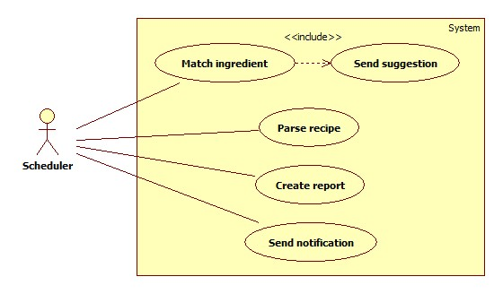

Figure 1 - <Scheduler> Overview Use Case

**<Scheduler> Send Notification**

**Use Case Diagram**

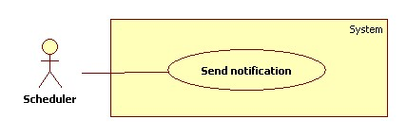

Figure 2 - <Scheduler> Send notification

**Use Case Specification**

|  |  |  |  |
| --- | --- | --- | --- |
| **USE CASE - <UC Number>** | | | |
| **Use Case No.** |  | **Use Case Version** | 1.0 |
| **Use Case Name** | Send notification | | |
| **Author** | Phan Hoang Giap | | |
| **Date** | 19/01/2016 | **Priority** | High |
| **Actor:**   * Scheduler   **Summary:**   * System can automatically notify user about expiring foods in refrigerator, foods are about to expire at specified time.   **Goal:**   * User is notified about their foods.   **Triggers:**   * The time hits configured time.   **Preconditions:**   * Notify time has been configured.   **Post Conditions:**   * Success: Foods information are sent to mobile app. Log file is generated. * Fail: Foods information are not sent to mobile app. Log file is generated.   **Main Success Scenario:**   |  |  |  | | --- | --- | --- | | **Step** | **Actor Action** | **System Response** | | **1** | Server checks the current time. If it hits 0 o’clock, scheduler starts. | * Get list of foods in user account. * Check food expiring day. * System send result message to mobile app. [Exception 1] * Generate log file. | | **2** | Server checks the current time. If it hits configured time, notify process start. | * Mobile app notify user about their foods. |   **Alternative Scenario:**   |  |  |  | | --- | --- | --- | | **No** | **Actor Action** | **System Response** | | **1** | If there is no food in user account | * Mobile app notify user:” There is no food in your refrigerator right now”. | | **2** | If there is no expired food or food is about to expire | * Do nothing. |   **Exception**   |  |  |  | | --- | --- | --- | | **No** | **Cause** | **System Response** | | **1** | System send message fail. | * Generate log file. |   **Relationships:** N/A  **Business Rules:**   * Log file structure:   Tạo file lúc: {Created date}, {Create time}   |  |  |  |  | | --- | --- | --- | --- | | STT | User account | Thời gian gửi | Gửi thành công/ thất bại | |  |  |  |  | |  |  |  |  |   Tổng thời gian: {Total elapsed time} | | | |

**<Scheduler> Match Ingredient**

**Use Case Diagram**

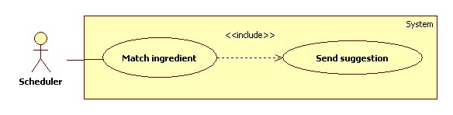

Figure 3 - <Scheduler> Match Ingredient

**Use Case Specification**

|  |  |  |  |
| --- | --- | --- | --- |
| **USE CASE - <UC Number>** | | | |
| **Use Case No.** |  | **Use Case Version** | 1.0 |
| **Use Case Name** | Send suggestion | | |
| **Author** | Phan Hoang Giap | | |
| **Date** | 19/01/2016 | **Priority** | High |
| **Actor:**   * Scheduler   **Summary:**   * System can suggest dish based on food in user’s refrigerator automatically at specified time.   **Goal:**   * User receive suggest dish.   **Triggers:**   * The time hits configured time.   **Preconditions:**   * There are at least 1 food in user refrigerator.   **Post Conditions:**   * Success: Dish information are sent to mobile app. Log file is generated. * Fail: Log file is generated.   **Main Success Scenario:**   |  |  |  | | --- | --- | --- | | **Step** | **Actor Action** | **System Response** | | **1** | Server checks the current time. If it hits 0 o’clock, scheduler starts. | * Get list of foods. * Matching from recipe database to suggest dishes. * System send result message to mobile app.[Exception 1] | | **2** | Server checks the current time. If it hits configured time, scheduler start send suggestion process. | * Mobile app notify user about their foods. |   **Alternative Scenario:**   |  |  |  | | --- | --- | --- | | **No** | **Actor Action** | **System Response** | | **1** | If there is no food in user account | * Mobile app notify user: “There is no food in your refrigerator right now”. | | **2** | If no dish is suggested after matching process | * Mobile app notify user “So sorry, no dish fit your foods” |   **Exception**   |  |  |  | | --- | --- | --- | | **No** | **Actor Action** | **System Response** | | **1** | System send message fail. | * Generate log file. |   **Relationships:** Match ingredient  **Business Rules:**   * Log file structure:   Tạo file lúc: {Created date}, {Create time}   |  |  |  |  | | --- | --- | --- | --- | | STT | User account | Thời gian gửi | Gửi thành công/ thất bại | |  |  |  |  | |  |  |  |  |   Tổng thời gian: {Total elapsed time} | | | |

**Parse Recipe**

**Use Case Diagram**

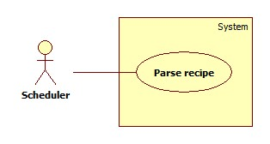

Figure 4 - <Scheduler> Parse Recipe

**Use Case Specification**

|  |  |  |  |
| --- | --- | --- | --- |
| **USE CASE - <UC Number>** | | | |
| **Use Case No.** |  | **Use Case Version** | 1.0 |
| **Use Case Name** | Get recipes by HTML parsing | | |
| **Author** | Phan Hoang Giap | | |
| **Date** | 19/01/2016 | **Priority** | High |
| **Actor:**   * Scheduler.   **Summary:**   * System can parse resource automatically from many websites at specified time.   **Goal:**   * Get resources from website.   **Triggers:**   * The time hits configured time.   **Preconditions:**   * Parse time has been configured.   **Post Conditions:**   * Success: New data is inserted to storage. Log file is generated. * Fail: Nothing is changed in the storage. Log file is generated.   **Main Success Scenario:**   |  |  |  | | --- | --- | --- | | **Step** | **Actor Action** | **System Response** | | **1** | Server checks the current time. If it hits 0 o’clock, scheduler starts parsing process. | * Send request to the chosen websites. * Fetch data based on configured file. * Validate data [Exception 1]. * If data is valid, insert to storage [Alternative 1]. * Generate log file. |   **Alternative Scenario:**   |  |  |  | | --- | --- | --- | | **No** | **Actor Action** | **System Response** | | **1** | Server checks the current time. If it hits 0 o’clock, scheduler starts parsing process. | * If fetched link resource is already in the storage, update its information. * Generate log file. |   **Exception**   |  |  |  | | --- | --- | --- | | **No** | **Actor Action** | **System Response** | | **1** | Data is invalid | * Generate log file. |   **Relationships:** N/A  **Business Rules:**   * If link resource exists in storage, do nothing. * If link resource is not active, do nothing. * Log file structure:   Tạo file lúc: {Created date}, {Create time}   |  |  |  |  |  |  | | --- | --- | --- | --- | --- | --- | | STT | Website | Thời gian parse | Tổng số công thức nhận được | Insert thành công | Insert thất bại | |  |  |  |  |  |  | |  |  |  |  |  |  |   Tổng thời gian parse:{Total elapsed time}  Tổng số công thức parse được:{Total parsed recipes} | | | |

**<Scheduler> Create Report**

**Use Case Diagram**

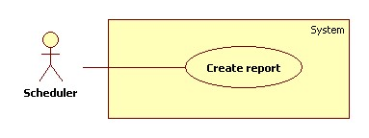

Figure 5 - <Scheduler Create report>

**Use Case Specification**

|  |  |  |  |
| --- | --- | --- | --- |
| **USE CASE - <UC Number>** | | | |
| **Use Case No.** |  | **Use Case Version** | 1.0 |
| **Use Case Name** | Create report | | |
| **Author** | Phan Hoang Giap | | |
| **Date** | 19/01/2016 | **Priority** | Normal |
| **Actor:**   * Scheduler   **Summary:**   * System can get user behavior as their searching foods, most appear foods in user refrigerator.   **Goal:**   * System can get user searching foods and most appear foods.   **Triggers:**   * 0 o’clock everyday   **Preconditions:**   * N/A   **Post Conditions:**   * Success: Log file is saved into storage. * Fail: Nothing is changed in the storage.   **Main Success Scenario:**   |  |  |  | | --- | --- | --- | | **Step** | **Actor Action** | **System Response** | | **1** | Server checks the current time. If it hits 0 o’clock, get log file from user’s mobile. | * Send request to get log file from mobile app. [Exception 1] * Saved log file to server. |   **Alternative Scenario: N/A**  **Exception**   |  |  |  | | --- | --- | --- | | **No** | **Actor Action** | **System Response** | | **1** | Send request fail. | * Show error message. |   **Relationships:** N/A  **Business Rules:**   * Log file structure:   Tạo file lúc: {Created date}, {Create time}   |  |  |  |  | | --- | --- | --- | --- | | STT | User account | Foods | Search keyword | |  |  |  |  | |  |  |  |  | | | | |